

**Software Engineering and Testing. BSC Year 2, 2024/2025**

**Assessment 2: Requirements Document**

**Submitted by:**

**RUBEN SOB B00166481**

**EMI HERDMAN B00165844**

**FRANKLIN OTWAMOAHENE ADDO B00159369**

**Submission date**

**Declaration**

I hereby certify that this material, which I now submit for assessment on the programme of study leading to the award of Ordinary Degree in Computing in the Institute of Technology Blanchardstown, is entirely my own work except where otherwise stated.

Author: Ruben Sob Dated: 21/02/2025

Author: Emi Herdman Dated: 21/02/2025

Author: Franklin Otwamoahene Addo Dated: 21/02/2025

**Table of Contents**

# Title: REF Solutions (A website for selling and buying Electronics)

# Client: Technophiles.

# Project Overview (1 paragraph)

The project is to develop a complete website for people interested in selling and buying of electronic devices. The website will provide descriptive summary of products and images as well as providing prices. The website will have a product page, home page, login page. The website can be used on large and small screens.

# Document Revision

Rev. 1.0 date – initial version

Rev. 2.0 – 21/02/2025

# Scope (max 1/2 page)

The project will require user authentication and validation that is login, register and password recovery. The project will have efficient and better way of handling user provided data, data including, processing, and structured storage. The project will provide an administrator to stock products on website and also give the opportunity to maintain the project. The project will incorporate a secure and reliable payment system for proper online transactions. The project will provide the customers an opportunity to cancel transactions if they do not like. Also, the project will provide history of their past transactions to allow them to search something the products.

1. **Walkthrough Scenarios**

Customers who are interested in electronics will be the ones who are going to use the website. The new clients will register and login securely while old customers will not need to register, they will have to login at hand. The home page will few section / products of the website as well as categories of the products on stock. Customers can navigate to the products page and select what product they prefer to purchase or use the search bar provided to look the particular product. They will now be taken the checkout page where they have choice to use different payment methods and provide their delivery method, customers can also cancel the transaction from the checkout if they are not interested again. Once customers are done with every transaction, the transaction is stored in their history page. Customers can also use a form provided to submit descriptions and images of items they wish to sell.

The administrator will login securely if they have credentials, if not they will have to register their credentials. Administrators will have the privileges to add new products to the product page, remove products as well.

1. **Software Requirements Analysis:**

# 5.1 User Requirements

* The website will allow users to register and also login securely.
* The website will allow users to view history of their transactions.
* The website will allow users to cancel transactions they wish to.
* The website will allow users to select the payment choice they want.
* The website will provide users with products page to select they wish.
* The website will provide a search bar for users.
* The website will provide forms to users to provide descriptions and images of products they wish to sell.

# 5.2 System Requirements

5.2.1 Use Cases

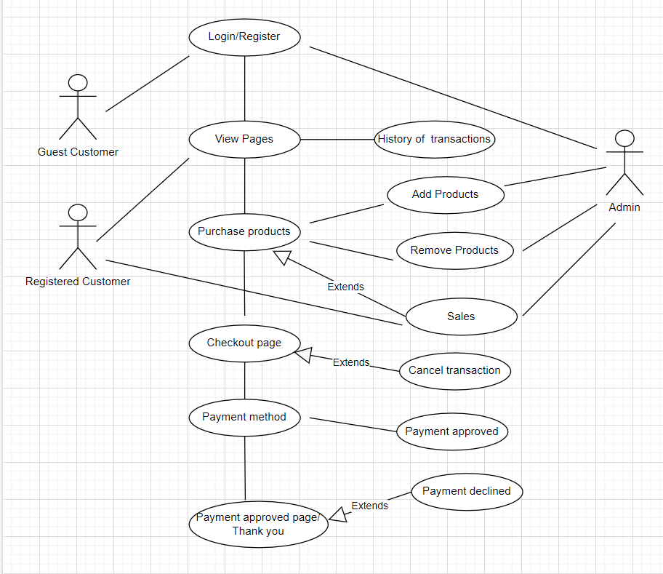

5.2.2 Use Case Specification

|  |  |
| --- | --- |
| View Pages | * View content and history of purchases. * Displays description and price of product. * Display images of products. |
| Login/Register | * Customers will provide email and password. * Authentication of customer. * Administrator will use username and password . * Authentication of the admin. |
| Add products | * Admin can add products to the products page using the database connected. |
| Remove products | * Admin can remove products from the products pages. |
| History of transaction | * History of purchases of customers will be provided using the database. |
| Cancellation of transaction | * Customer can enter transaction details * System makes request to the database to search the exact transaction. * Database return the transaction details to the system. * System display reservation to the customer.   • Customers must confirm the transaction • Database delete the transaction.   * Database send the refund to the system. * System sends refund information to the customer. |
| Sales | * Customers can view products that are on sale. * Admin can stock products that are on sales on the website. |
| Checkout | * Display the list of products alongside the price. * Breaks the entire cost of the purchase to the customer. |

5.2.3 Activity Diagrams

* Customers logins or registers
* Customers browse products and also search for products
* Customers add products to cart
* Payment system is processed
* Customers make payment and confirm delivery details
* Customers can cancel transactions
* Admin can add as well as remove products from website
* Admin can add sales products

# 5.3 Non-functional Requirements:

**Review**

Customers will have privilege to see what other customers said about a particular product whether good or bad in order for them to decide.

**Return**

Customers will have the ability to return a product they wish after a period of time of purchase.

**Maximum transaction**

Customers will be allowed to a certain number of purchases per a particular product depending on the stock available.

**Age restrictions**

There may be age restrictions on some products because of certain age group may not be able to handle some electronics while other age groups are allowed to.

**Payment method**

There will be several payment methods for customers to use depending on what they prefer. This gives the customers flexibility.

# Graphical User Interface Design

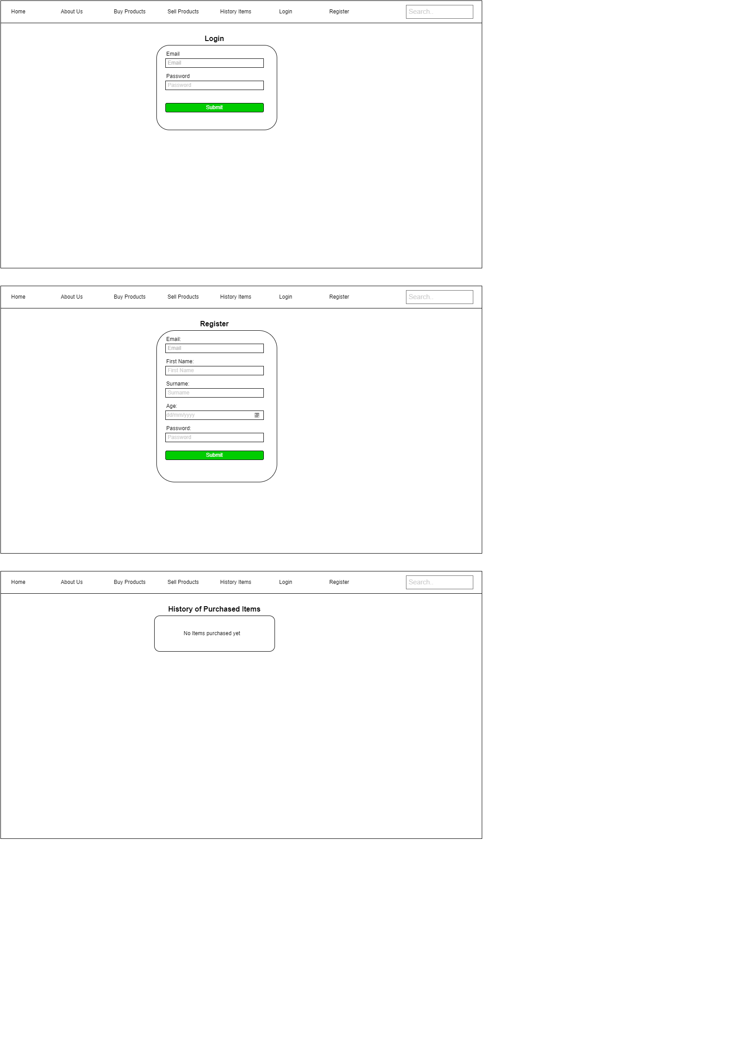

# Technical Requirements and Feasibility:

**System models**

The project will be designed using use case diagrams, use case specifications and also UML.

**Development language**

The project will be developed using PHP, html as well as CSS.

**Persistent storage**

The project will need a relational database to store and manage data. MySQL is the preferred one to be used.

**Interface & Software / Hardware APIs**

The project will be in a web form. The project will be developed to work with large or small screens.

## Conclusion (1-2 paragraphs)

Your conclusions and recommendations (feasibility of the proposed project)

Based on the provided documentation for the project, it concludes that the project can successfully be developed. The use of UML helps in clear communication with the client, also the use of use case specifications help builds database for the project. The languages that will be used is well known, this will make the project easier to develop and maintain as well as. The database also helps to handle data within the project.

Also, I recommend the database is carefully developed to avoid errors resulting in displaying the content. The workload shared properly, and everyone should be held accountable for their part in order to complete the project on time.

Additional sections: Table of Contents, executive summary, Index

Checklist: Is your document complete and correct?

*Content:*

* Do the requirements state the customers’ needs
* Are you satisfied with all parts of the document
* Do you believe all parts are possible to implement
* Is each part of the document in agreement with all other parts
* Do the requirements avoid specifying a solution
* Do the requirements avoid specifying a design

*Completeness*:

* Are all the necessary interfaces specified – this includes input and output
* Are the specifications precise enough
* Are all sections from the document template included – if changed, why?

*Clarity*:

* Are all requirements reasonable?
* Is the level of details for each requirements appropriate?
* Are the requirements written in a language appropriate to the reader?
* Are all items clear and unambiguous?